|  |  |  |  |  |  |  |  |  |  |  |  |  |  |  |  |  |
| --- | --- | --- | --- | --- | --- | --- | --- | --- | --- | --- | --- | --- | --- | --- | --- | --- |
| **Qualification details** | | | | | | | | | | | | | | | | |
| **Training Package Code and Title:** | | ICT - Information and Communications Technology (Release 7.2) | | | | | | | | | | | | | | |
| **Qualification National Code and Title:** | | ICT40120 Certificate IV in Information Technology  (Release 2) | | | | | | | | | | **State code:** | | | | BFF9 |
| **Assessment Title** | | Assessment Task Two Team Project | | | | | | | | | | | | | | |
| **Unit National Code & Title** | | ICTPRG440 Apply introductory programming skills in different languages | | | | | | | | | | | | | | |
| ICTPRG437 Build a user interface | | | | | | | | | | | | | | |
| ICTICT435 Create technical documentation | | | | | | | | | | | | | | |
| **Due Dates** | | Sprint One: Week Ten | | | | | | **Date Received** | | | | | | |  | |
| Sprint Two: Week Thirteen | | | | | | **Date Received** | | | | | | |  | |
| Handover: Week Fourteen | | | | | | **Date Received** | | | | | | |  | |
| **Student Name** | |  | | | | | | | | | **Student ID** | | | | |  |
| **Student Declaration** | | I declare that the evidence submitted is my own work:  ………………………………………….. | | | | | | | | | | | | | | |
| **Assessor Name** | |  | | | | | | | | | | | | | | |
| **Assessment Decision** | |  | Satisfactory | | | |  | | Not Yet Satisfactory | | | | | | | |
| **Assessor Signature** | |  | | | | | | | **Date** | | | | |  | | |
| **Is student eligible for reassessment (Re-sit)?** | |  | | No |  | Yes | | | **Reassessment Date:** | | | | | Week Twenty | | |
| **Feedback to student** | | | | | | | | | | | | | | | | |
| *Via Blackboard (LMS) – Please check [Grade] section.* | | | | | | | | | | | | | | | | |
| **Feedback from student** | | | | | | | | | | | | | | | | |
| *Via Blackboard (LMS) – Please use [Comment] section during submission.* | | | | | | | | | | | | | | | | |
| **Student signature** |  | | | | | | | | | **Date** | | |  | | | |

## 

## Rapid Application Team

In Sprint One and Sprint Two each team member assumed the role of Scrum Master and Team Member; in this final task all team members are equal and share the responsibility to complete all the assessment criteria.

You should consult with the CITEMS representative (Your Lecturer) if you are unsure about any of the problems or questions in this assessment. Your primary research should focus on the resources on the Blackboard website, additional information can be collected from the Internet, ensure all sources are fully referenced. You should write your answers in one of the standard templates provided on Blackboard.

# Handover

The client has accepted the sprint one and sprint two development milestones for the Astronomical Processing application. The final stage is to conduct testing on all methods that calculate the four mathematic functions. This is to validate the accuracy of the methods.

The client wants the tests recorded in a formal Test Report with associated screen captures of the debug session which traces the changing values for each of the four functions. Use the following client requirements and complete the Test Report by recording the testing of the four mathematical methods.

### Client Requirements

* All four mathematical methods are tested (mid-extreme, mode, average and range).
* The results of the tests are recorded in the formal Test Report.
* Each mathematical function is tested more than three times.
* Each mathematical method has a break point.
* Each mathematical method has local variables displayed in a watch.

### Testing

Read the Client Requirements and ensure all relevant information is included in the Test Report. This is a team effort so the team should meet and discuss how each of the four mathematical functions can be fully tested. The meeting should consider what type of data will be required for each mathematical function and reflect the organisational guidelines of CITEMS (refer www.citems.com.au/). Use the Test Report during the test session, add additional rows as required and include suitable screen captures to support each test case. Where the testing highlights an issue in the Astronomical Processing application you can updated the code and record this change to ensure all client requirements and testing are satisfactory.

## Question Fifteen

### Instructions

Fill in all sections of the Test Report, start by completing the Project Details. Then list all the Test Cases and the associated Test Steps. Run the tests and record the results. Review the results and modify the code to ensure correct functionality of the application.

|  |  |  |  |  |  |  |  |  |
| --- | --- | --- | --- | --- | --- | --- | --- | --- |
| Test Report | | | | | | | | |
| Project Details | | | | | | | | |
| Date | | 19/10/2021 | | | | | | |
| Team Name | | Team Elljam | | | | | | |
| Team Members | | James Boyd | | | Ellena Begg | | | |
| Test Type | | **Test using breakpoints and watch panel** | | | | | | |
| Test Case # | Test Case Name | | Test Steps | Test Data | | Expected Results | Evidence  (ref to Screen Capture) | Pass / Fail |
| 1 | Mid-extreme test 1 | | Click mid-extreme button with no data in array | none | | Error message saying “cannot calculate…” | Ref mid extreme test 1, figures 1, 2 | Pass |
| 2 | Mid-extreme test 2 | | Add numbers to list box manually and click mid-extreme button | 1, 2, 3, 4, 5 | | 3.00 | Ref mid extreme test 2, figures 1, 2 | Pass |
| 3 | Mid-extreme test 3 | | Fill array with ‘Fill Array’ button, click mid-extreme button | Minimum 13  Maximum 98 | | 55.50 | Ref mid extreme test 3, figures 1, 2 | Pass |
| 4 | Mid-extreme test 4 | | Fill array with ‘Fill Array’ button, click mid-extreme button to test different data | Minimum 16  Maximum 96 | | 56.00 | Ref mid extreme test 4, figures 1, 2 | Pass |
| 5 | Mode test 1 | | Click mode button with no data in array | none | | Error message “Cannot calculate…” | Ref mode test 1, figures 1, 2 | Pass |
| 6 | Mode test 2 | | Fill array with ‘Fill array’ button, click Mode button to find mode | Data set with 27 and 35 repeated | | Mode = 35 | Ref mode test 1, figures 1, 2 | Pass |
| 7 | Mode test 3 | | Continue from last test, delete one instance of ‘35’ | Data set with 27 | | Mode = 27 | Ref mode test 1, figures 1, 2 | Pass |
| 8 | Mode test 4 | | Fill array with ‘Fill array’ button, manually remove all repeated numbers | Data set with no repeated numbers | | User message “No mode found” | Ref mode test 1, figures 1, 2 | Pass |
| 9 | Average test 1 | | Click Average button with no data in array | none | | Error message “cannot calculate…” | Ref average test 1, figures 1, 2 | Pass |
| 10 | Average test 2 | | Manually add numbers to array and click Average button | 10, 20 | | 15.00 | Ref average test 1, figures 1, 2 | Pass |
| 11 | Average test 3 | | Fill array with ‘Fill Array’ button, click Average button | 13, 17, 75, 88, etc | | 60.21 | Ref average test 2, figures 1, 2 | Pass |
| 12 | Average test 4 | | From above, click Sort, click Average again to ensure average does not change | Same as above | | 60.21 | Ref average test 3, figures 1, 2 | Pass |
| 13 | Range test 1 | | Click Range button with no data in array | none | | Error message “Cannot calculate…” | Ref average test 4, figures 1, 2 | Pass |
| 14 | Range test 2 | | Fill array with ‘Fill Array’ button, click Range button | Minimum 13  Maximum 89 | | 76.00 | Ref range test 1, figures 1, 2 | Pass |
| 15 | Range test 3 | | From above, click Sort button, click Range button to ensure average does not change | Minimum 13  Maximum 89 | | 76.00 | Ref range test 2, figures 1, 2  Ref range test 3, figures 1, 2 | Pass |
|  | Range test 4 | | Manually add two identical numbers | 100, 100 | | 0 | Ref range test 4, figures 1, 2 | Pass |

## Mid-extreme test 1 figure 1:

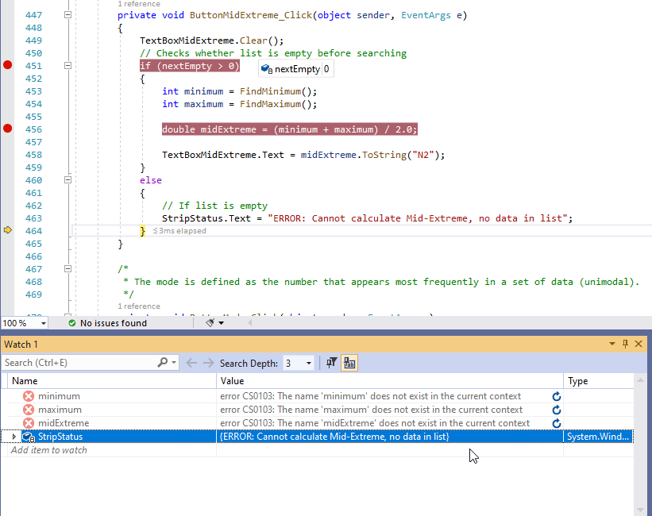

## Mid-extreme test 1 figure 2:

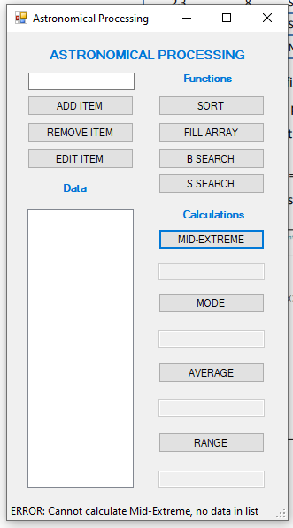

## Mid-extreme test 2 figure 1:

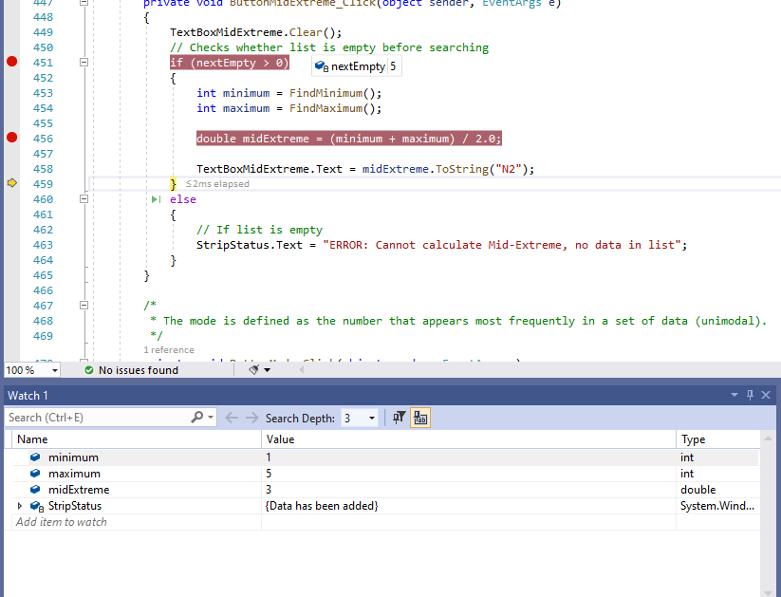

## Mid-extreme test 2 figure 2:

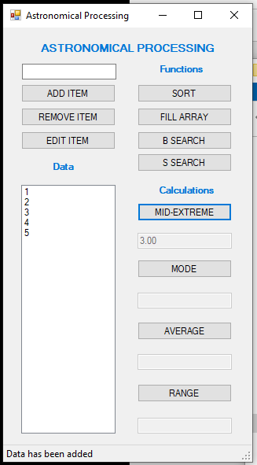

## Mid-extreme test 3 figure 1:

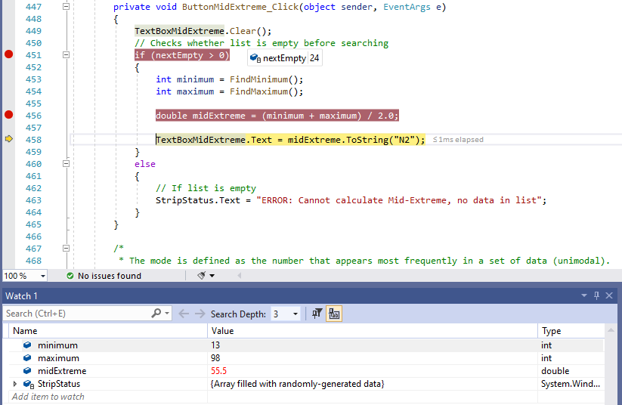

## Mid-extreme test 3 figure 2:

## 

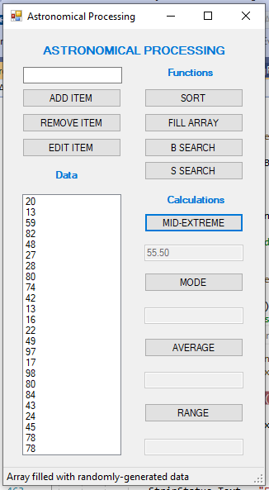

## Mid-extreme test 4 figure 1:

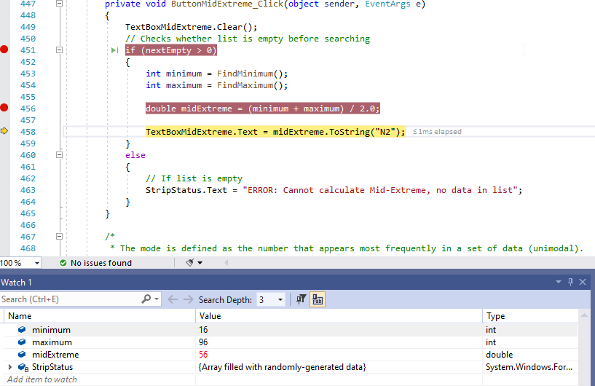

## Mid-extreme test 4 figure 2:

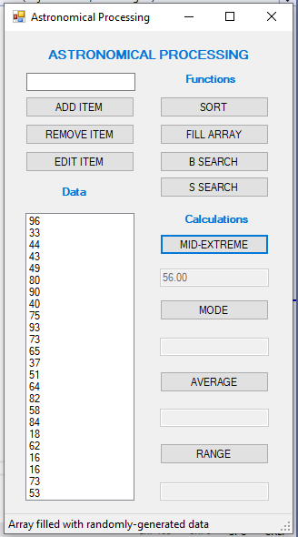

## Mode test 1 figure 1:

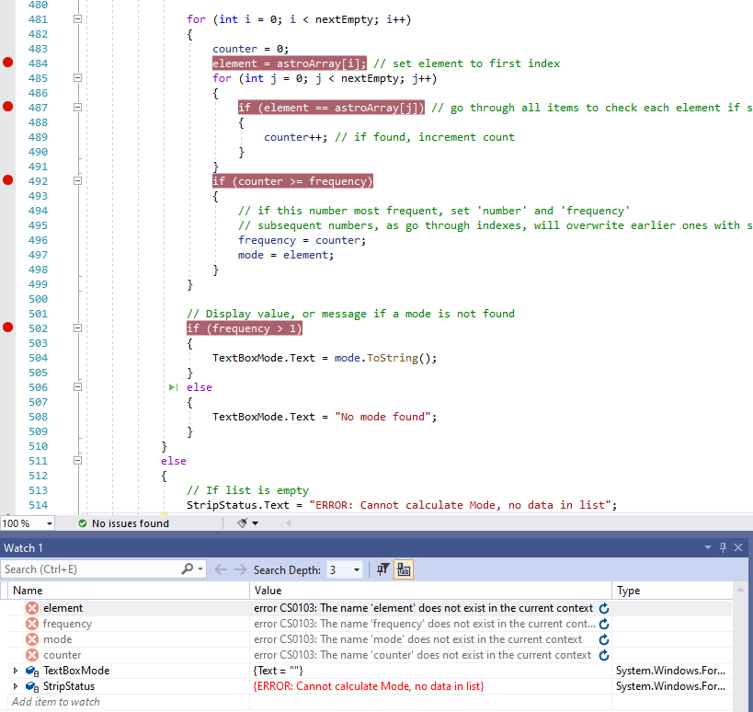

## Mode test 1 figure 2:

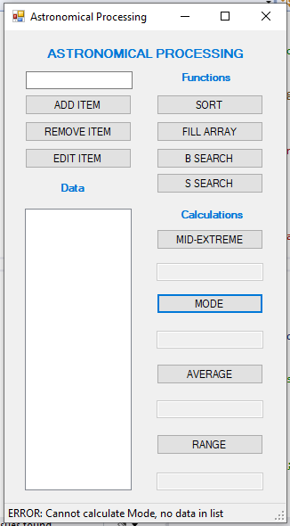

## Mode test 2 figure 1:

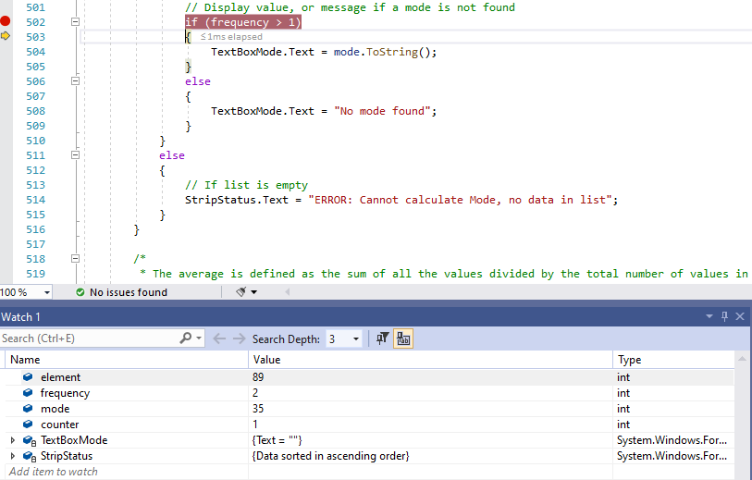

## Mode test 2 figure 2:

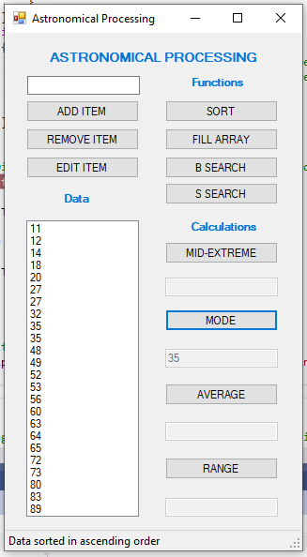

## Mode test 3 figure 1:

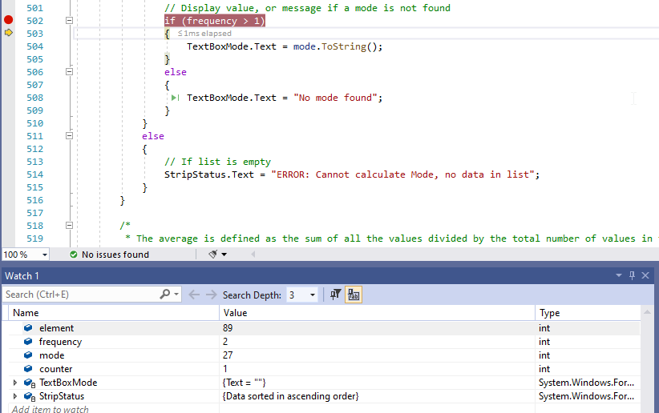

## Mode test 3 figure 2:

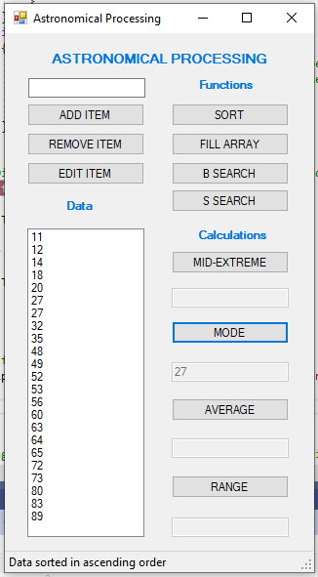

## Mode test 4 figure 1:

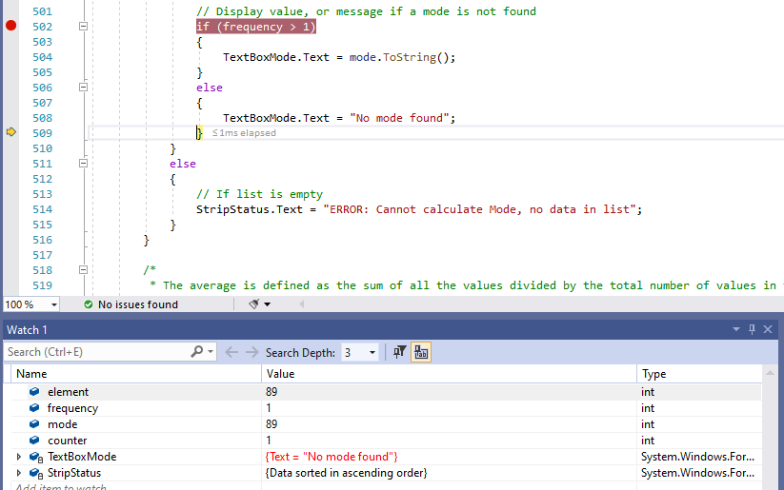

## Mode test 4 figure 2:

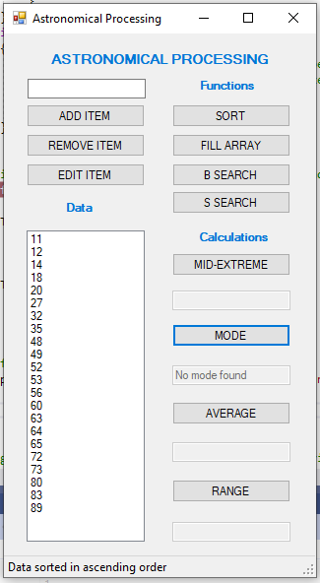

## Average test 1 figure 1:

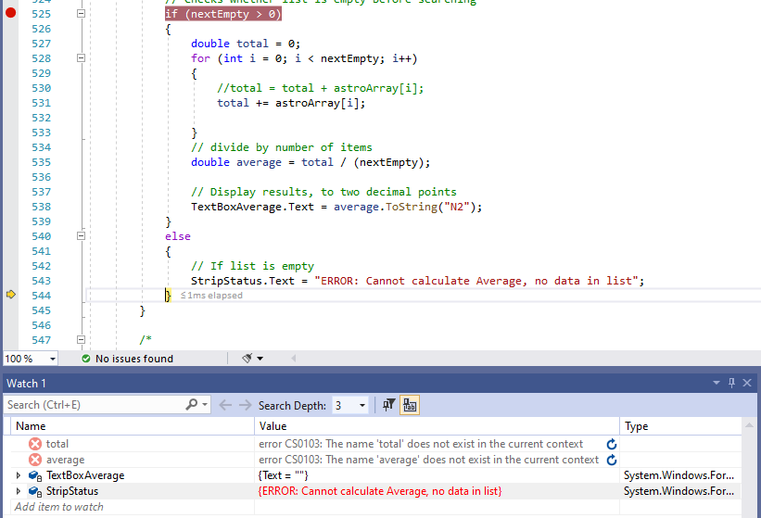

## Average test 1 figure 2:

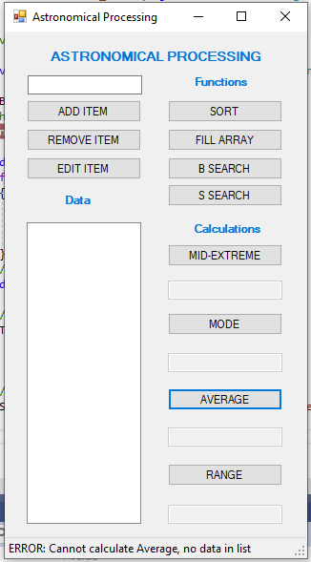

## Average test 2 figure 1:

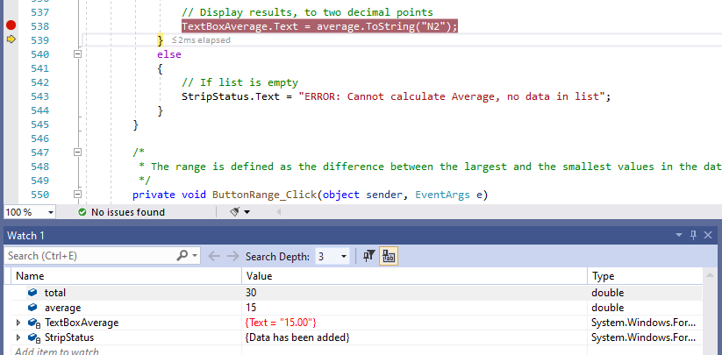

## Average test 2 figure 2:

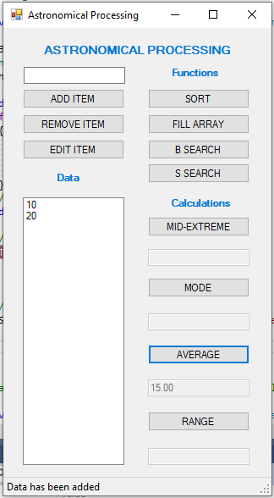

## Average test 3 figure 1:

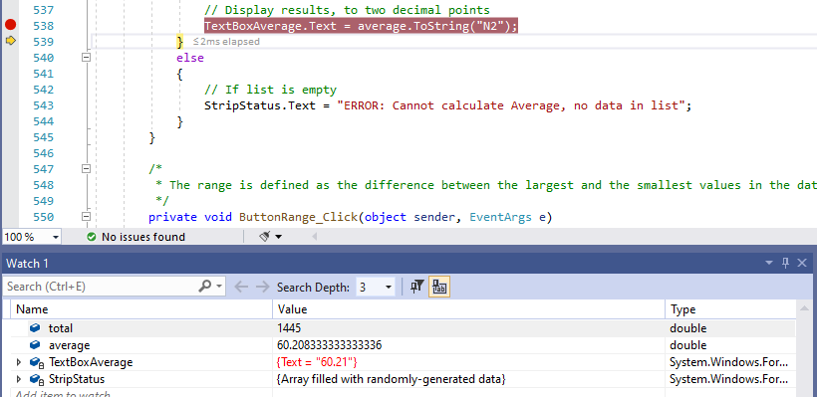

## Average test 3 figure 2:

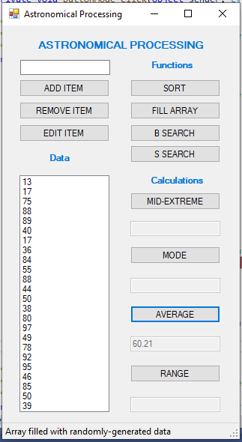

## Average test 4 figure 1:

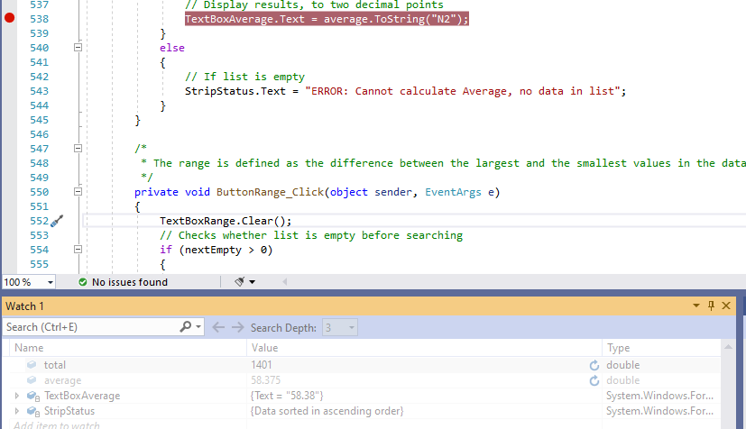

## Average test 4 figure 2:

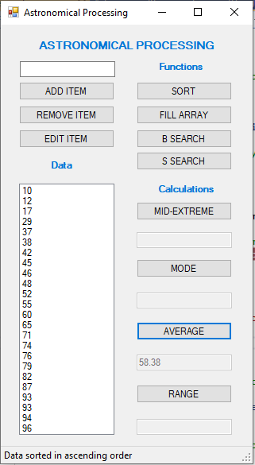

## Range test 1 figure 1:

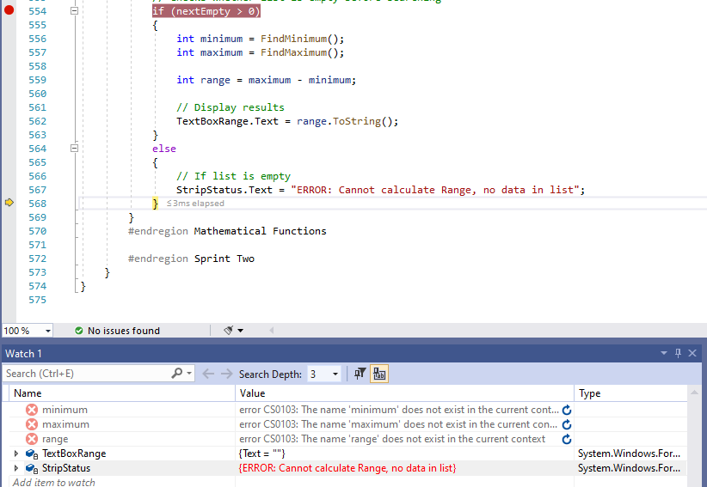

## Range test 1 figure 2:

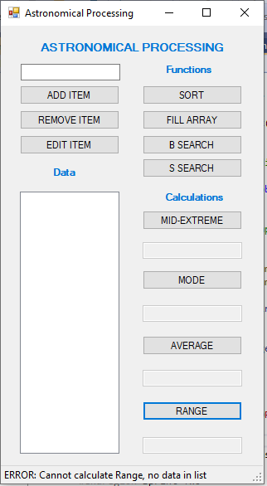

## Range test 2 figure 1:

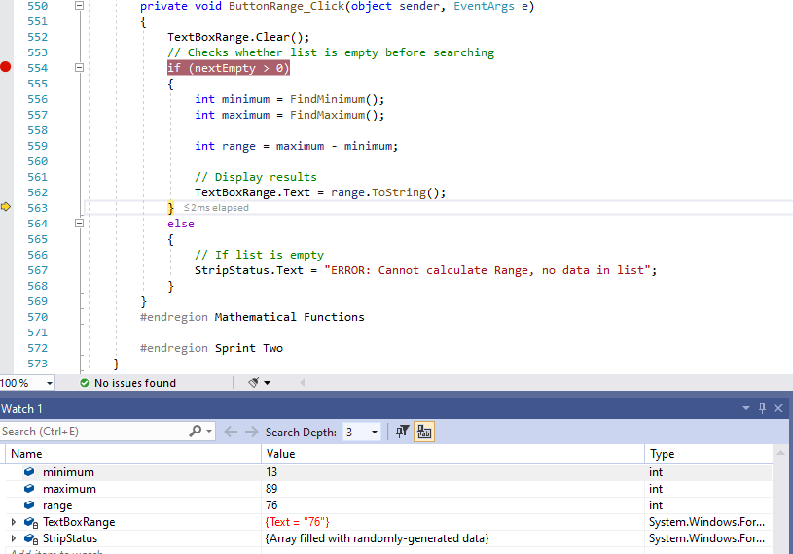

## Range test 2 figure 2:

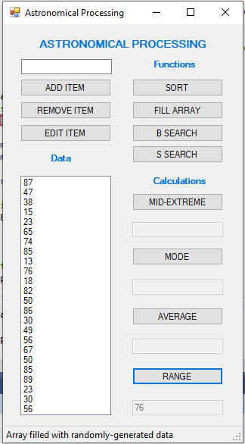

## Range test 3 figure 1:

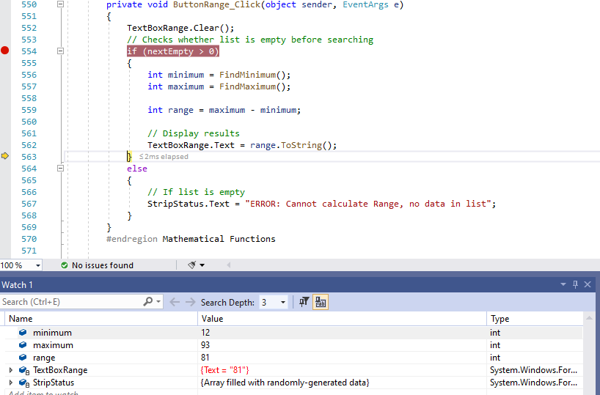

## Range test 3 figure 2:

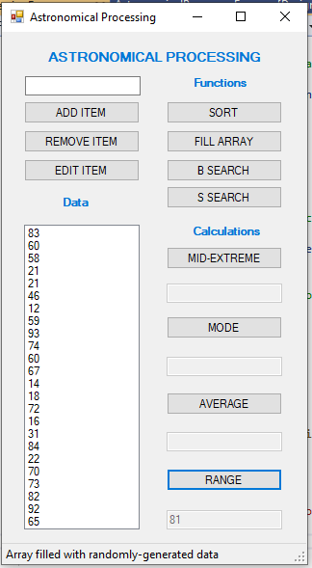

## Range test 4 figure 1:

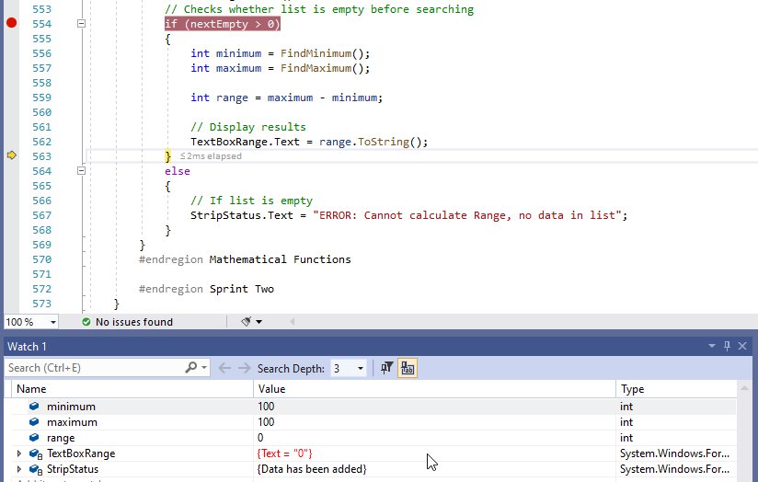

## Range test 4 figure 2:

## Submission Requirements

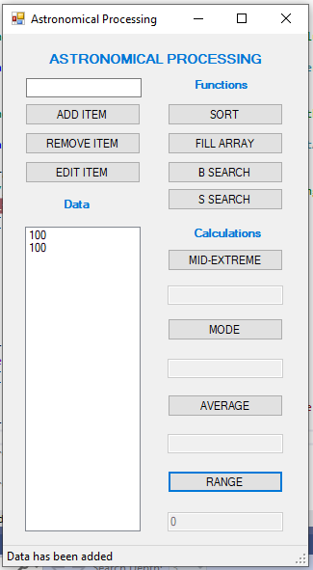

Your submission for the Handover will include:

Completed Test Report from Question Fifteen,

Completed Solution Folder for the Astronomical Processing application.

Your team will submit the working program and Test Report documentation to the appropriate Blackboard section. The following Marking Guide should be used to ensure all aspects of the final Handover assessment are covered. Consult your lecturer for further information or clarification.

|  |  |  |  |
| --- | --- | --- | --- |
| Assessment Task Two Handover  Marking Guide | | | |
| Student Name | __________________________ | | |
| Criteria | Satisfactory | | Comment |
| 1. The test data is suitable for each test case and reflects the design and development requirements. | Yes | No |  |
| 1. The test results are support with screen captures. | Yes | No |  |
| 1. The Test Report is complete. | Yes | No |  |
| 1. All documentation is properly formatted | Yes | No |  |
| 1. Participated in both sprints | Yes | No |  |
| 1. Participated in the testing/handover | Yes | No |  |
| 1. Active and supportive team members | Yes | No |  |

|  |  |  |  |  |  |
| --- | --- | --- | --- | --- | --- |
| **Assessor Name** |  | | | | |
| **Assessment Decision** |  | Satisfactory |  | Not Yet Satisfactory | |
| **Is student eligible for reassessment (Re-sit)?** | No | Yes | **Reassessment Date:** | |  |
| **Assessor Signature** |  | | **Date** | |  |

|  |  |  |  |
| --- | --- | --- | --- |
| **Feedback to student** | | | |
|  | | | |
| **Student signature** |  | **Date** |  |

**NOTE to Assessor: This is an individual submission. Please complete one checklist per student.**

End of Assessment